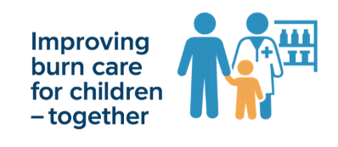
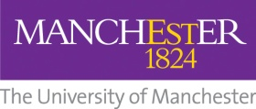

Community pharmacists are invited to take part in a UK burns survey

Community pharmacists are invited to participate in a new UK research study exploring confidence, experience and referral practice when managing burn injuries in children.

Community pharmacies are often a first point of contact for families when a child has a burn injury, yet there is limited evidence describing current pharmacy practice in paediatric burn care. This study aims to help address this gap and inform future education and support.

🔹 10-minute online survey
🔹 Anonymous and ethically reviewed
🔹 Open to all UK community pharmacists

The research is led by the University of Manchester in collaboration with NHS burns specialists and pharmacy partners. Findings will help shape future training resources and improve care pathways for children with burn injuries.

Further information can be found in the Participant Information Sheet (PIS).

Please support this project by completing the survey and sharing it with your pharmacy colleagues via e-mail and social media. (social media content)

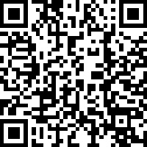
Survey QR code:

Survey link: https://www.qualtrics.manchester.ac.uk/jfe/form/SV_7376fVxC1BFR7gi?Q_CHL=qr

Thank you for supporting this important piece of work.

Contact for further information about the study
Professor Mamta Shah
Consultant Burns and Plastic Surgeon
Royal Manchester Children’s Hospital & University of Manchester
mamta.shah@manchester.ac.uk

